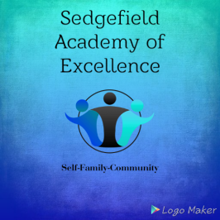

**Internet Consent Form 2022**

During the course of the year, Sedgefield Academy of Excellence will be taking photographs of the children doing some of their daily fun activities. We will also be taking photographs of the children during their outings/trips and on special occasions.

I, the undersigned, hereby give my consent for my child ___________________________________________

to be photographed by Sedgefield Academy of Excellence and the photographs to be used on the Academy’s webpage/Facebook page or for News articles throughout the year.

Any objection against the abovementioned will be lodged in writing by the parent/guardian, and addressed directly to Management. Although great care will be taken upon receipt of the stated objection not to include the above child in any photographs taken, it may occur that my child inadvertently appears in a photograph together with another child/other children who have not lodged such an objection. I accordingly indemnify Sedgefield Academy of Excellence.

Signature of consent: ___________________________________________________________________________

Name and Surname of parent/guardian: ____________________________________________________________

Dated this _____________ day of ______________________________ 20_____